# Note

Starting at 10.8, instances of ArcGIS Web Adaptor running on IIS web servers enable [the WebSocket protocol](https://docs.microsoft.com/en-us/iis/configuration/system.webserver/websocket) by default. No action is needed. Previously, enabling WebSocket was an essential part of ArcGIS Notebook Server installation, as the protocol is required for notebooks to work with the Web Adaptor.

# **Common problems and solutions**

<https://enterprise.arcgis.com/en/portal/latest/administer/windows/common-problems-and-solutions.htm>

# Check system health

## Validate Server Data Store

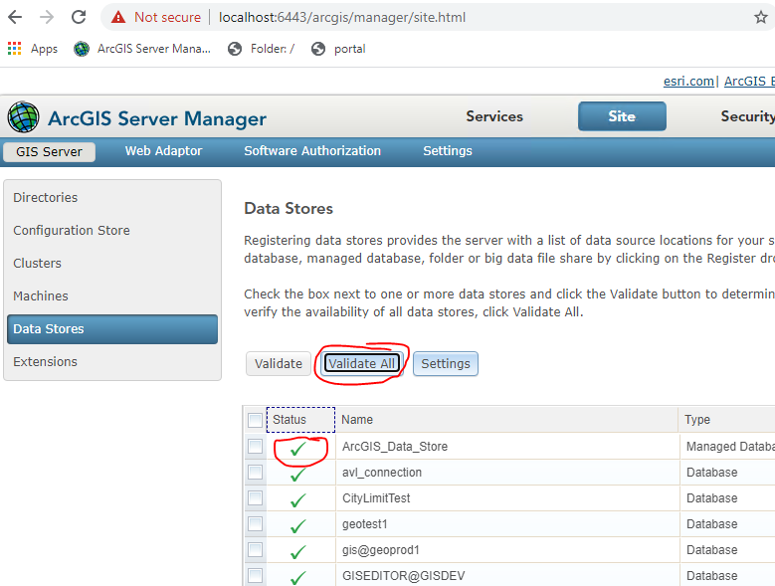

## Check portal Index. 🡪 Index not match🡪 Reindex.

<https://maps.garlandtx.gov/cogmap/portaladmin>

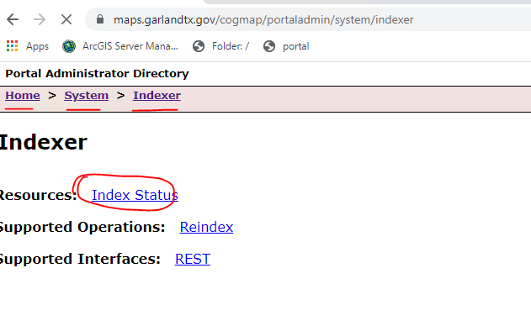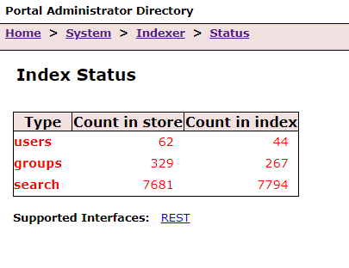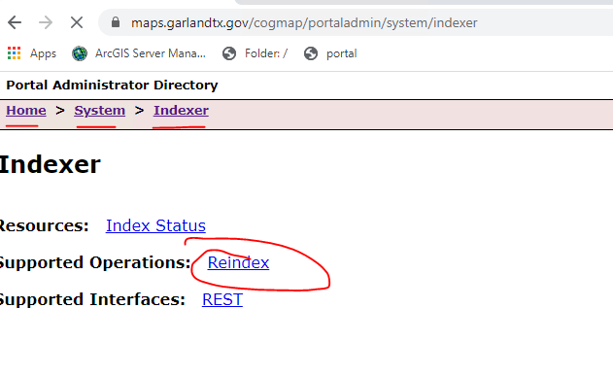

# Backup

## Snapshot

## WebGISDR

* Recover to a different server, test and make sure the backup works, before upgrade.

E:\Program Files\ArcGIS\Portal\tools\webgisdr

#### backup

The backup for each component is placed in a temporary directory on each component's machine before being moved to the shared directory you specify. Therefore, the following directories must be large enough to contain the backup of each component:

* Portal for ArcGIS: <Portal_content_directory>\temp
* ArcGIS Server: C:\Users\<user>\AppData\Local\Temp
* ArcGIS Data Store: <ArcGIS_Data_Store_directory>\temp

ArcGIS Data Store | ArcGIS Server |Portal

https://enterprise.arcgis.com/en/portal/latest/administer/windows/create-web-gis-backup.htm

1. Copy webgisdr.properties ( E:\Program Files\ArcGIS\Portal\tools\webgisdr) to a different location(E:\webgisdrprofiles), and update it.
2. Run with cmd

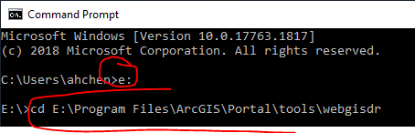

webgisdr –export –file E:\webgisdrprofiles\webgisdr.properties

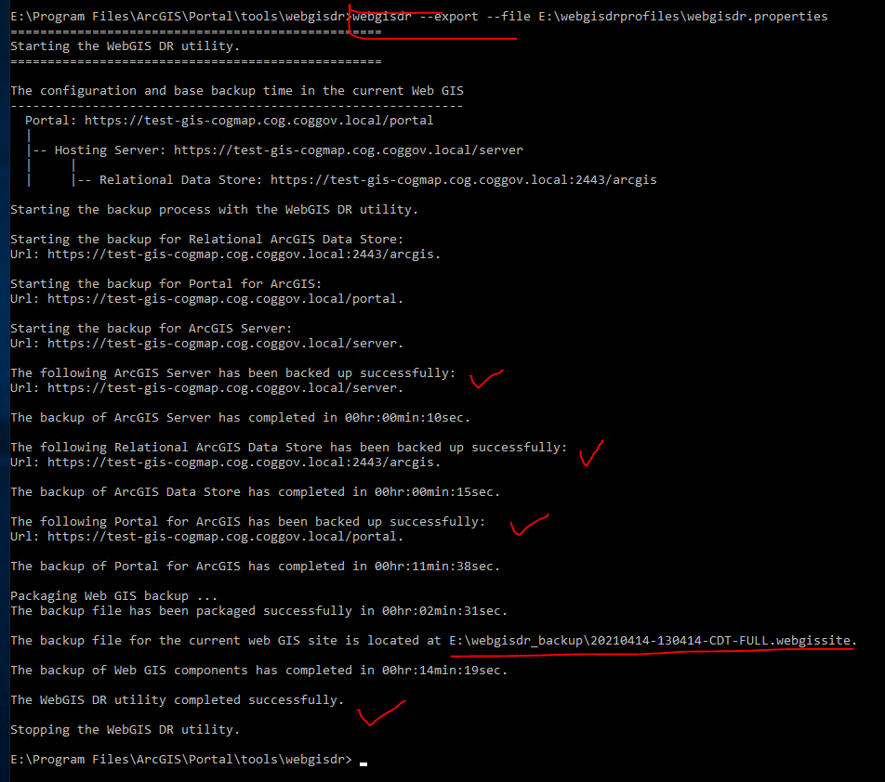

#### ----recovery

Note that the property file does not have to be in the same folder you saved it in when first created. If you do move it, specify the new folder location with the --file parameter.

<https://enterprise.arcgis.com/en/portal/latest/administer/windows/restore-web-gis.htm>

cd E:\Program Files\ArcGIS\Portal\tools\webgisdr\

webgisdr --import –file E:\webgisdrprofiles\webgisdr.properties

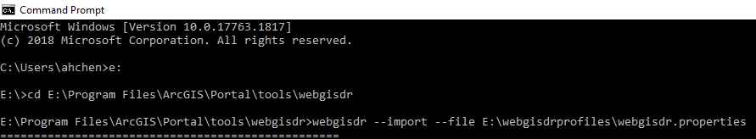

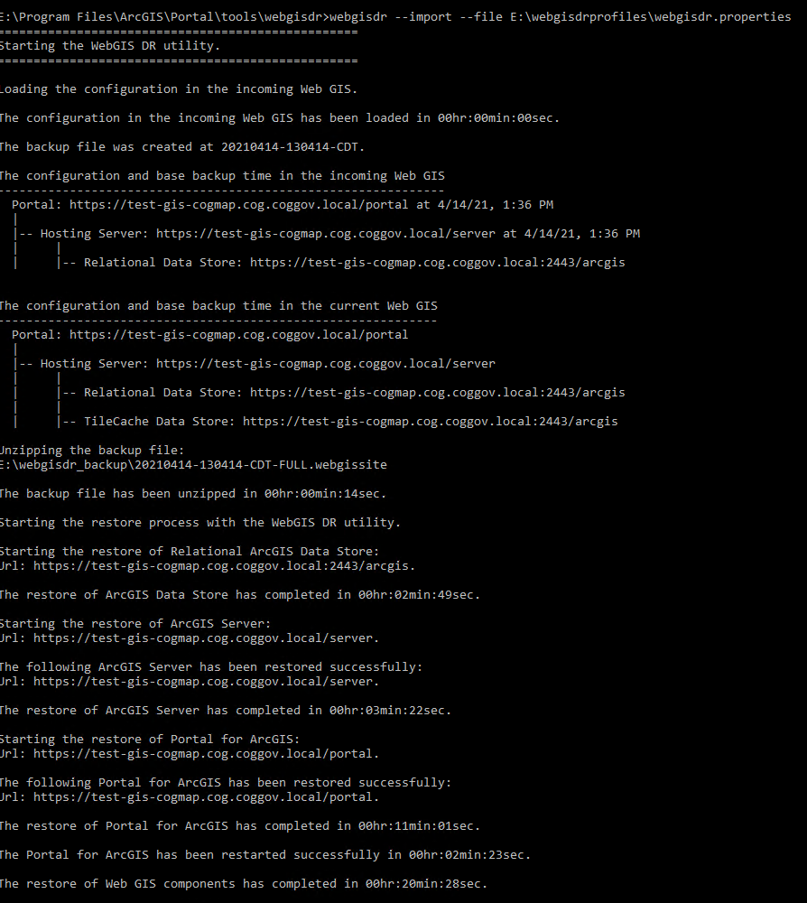

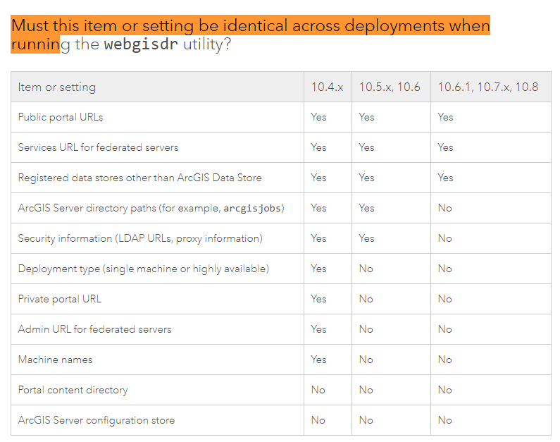

#### Recovery to a different machine

**Steps to migrate distributed environments**

<https://www.esri.com/arcgis-blog/products/arcgis-enterprise/administration/migrate-to-a-new-machine-in-arcgis-enterprise-two/>

<https://community.esri.com/t5/arcgis-enterprise-questions/import-fails-with-webgisdr-public-portal-urls-different/m-p/582507>

1. Install ArcGIS Server/ ArcGIS Portal/ DataStore

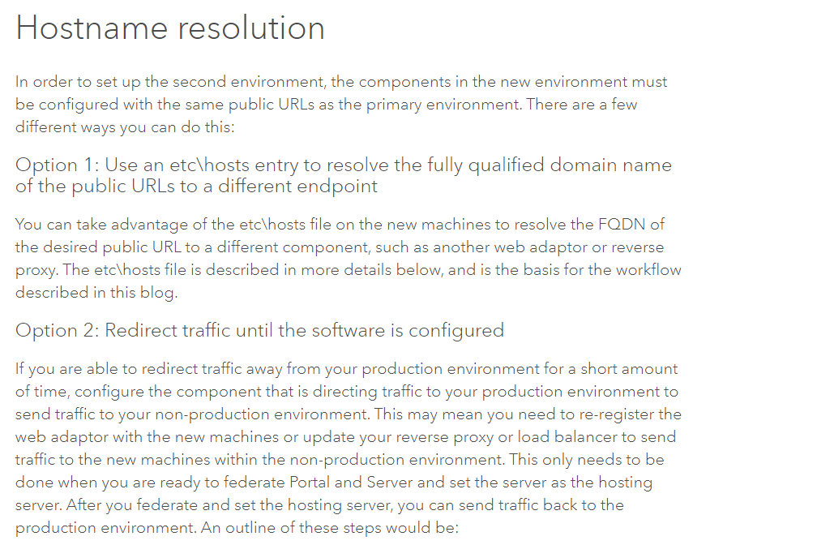

My steps---

* First Try

1. ~~Stop services --- wrong~~
2. ~~Copy files ---- wrong~~
3. ~~Update webgisdr.properties file~~

* ~~Failed！！！~~
* Second try

1. ~~C:\Windows\System32\drivers\etc， update hosts file~~

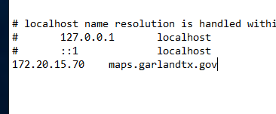 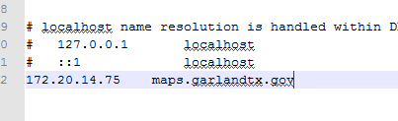

1. Create server site and portal site,and datastore site
2. ~~Install web adaptor~~
3. ~~Server webadaptor~~

~~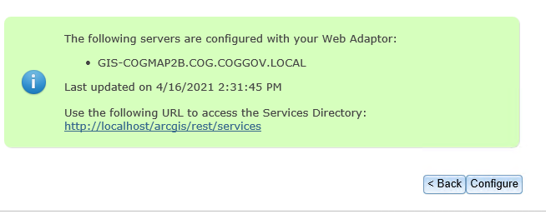~~

1. ~~Portal webadaptor:~~

[~~https://maps.garlandtx.gov/cogmap/webadaptor/portal~~](https://maps.garlandtx.gov/cogmap/webadaptor/portal)

~~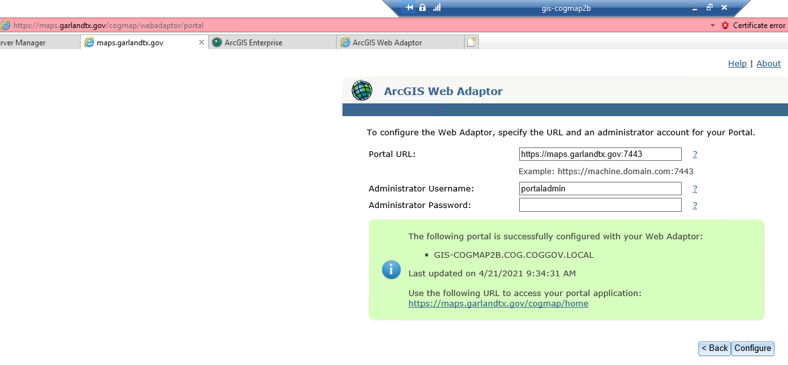~~

1. ~~Run the DR restore.~~
2. ~~Failed！！！~~

* Third Try-
  1. C:\Windows\System32\drivers\etc， update hosts file on test-gis-dbs1 and gis-cogmap2b – 172.20.14.75 is the ip of test-gis-dbs1, and restart



* 1. Create Server site and portal site
  2. Install and setup datastore
  3. ----snapshot 04222021
  4. Install web adaptor on test-gis-dbs1.
  5. Setup web adaptor

Maps.garlandtx.gov/arcgis/webadaptor

Maps.garlandtx.gov/cogmap/webadaptor

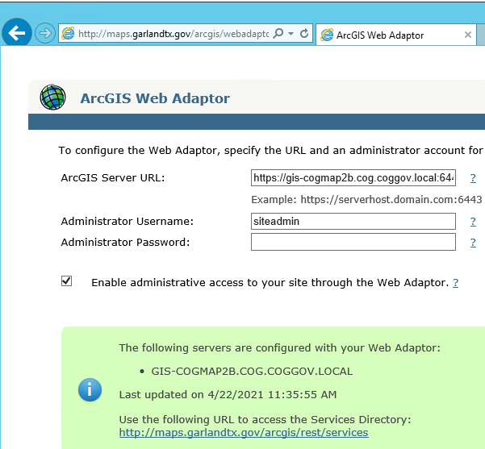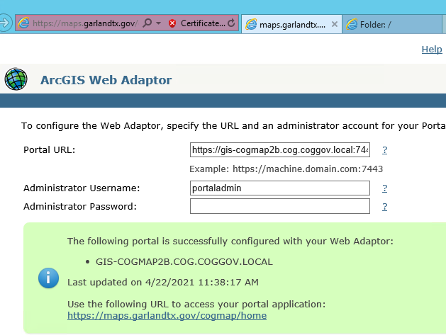

<https://gis-cogmap2b.cog.coggov.local:6443>

<https://gis-cogmap2b.cog.coggov.local:7443>

--- server setup done.

* 1. Recovery

Update webgisdr. properties file

cd E:\Program Files\ArcGIS\Portal\tools\webgisdr\

webgisdr --import –file E:\webgisdrprofiles\webgisdr.properties

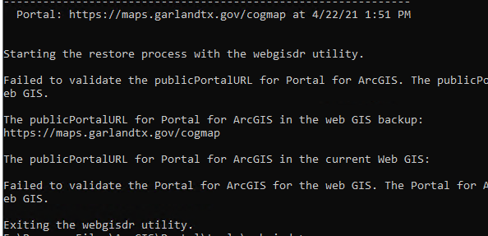

* 1. Failed several times. Give up.

____

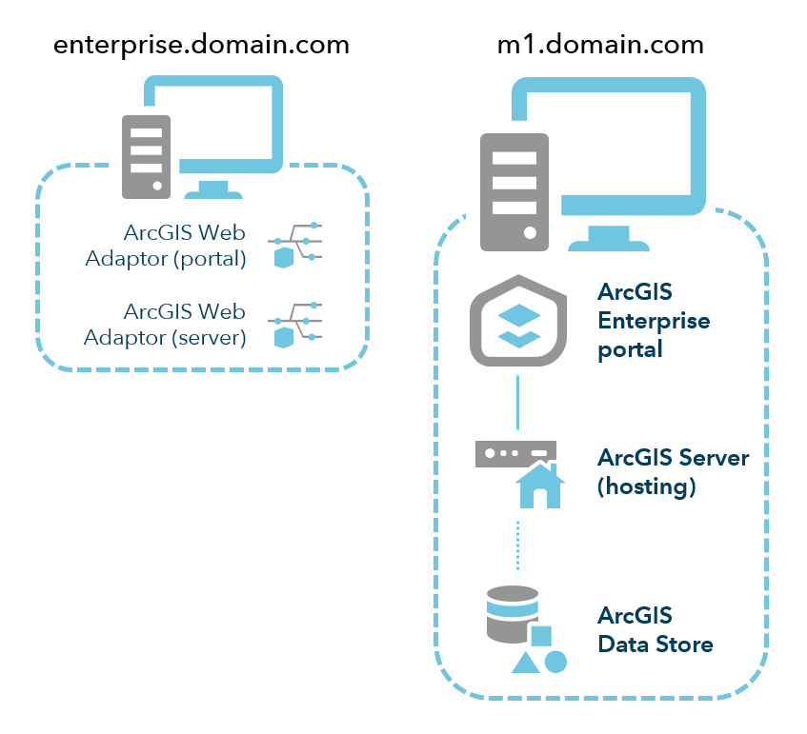

## Folders

* + E:\arcgisportal
  + E:\arcgisserver
  + E:\arcgisdatastore
  + E:\Map_Docs
  + E:\Map_Data
  + E:\sde_script
  + E:\Softwhere
  + E:\sde_connection
  + E:\Program Files\ArcGIS\Server\usr

# Upgrade 🡪 to follow the order below

## Download 10.8.1 Portal Install file, and 10.8.1 Server Install file.

## Portal

* 1. get portal json license first.
  2. Install

(password: Gxxxxxxxx)

* 1. Import license file (json) and continue portal upgrade

(license files can’t be imported from desktop. I put it under E:\ and it worked.)

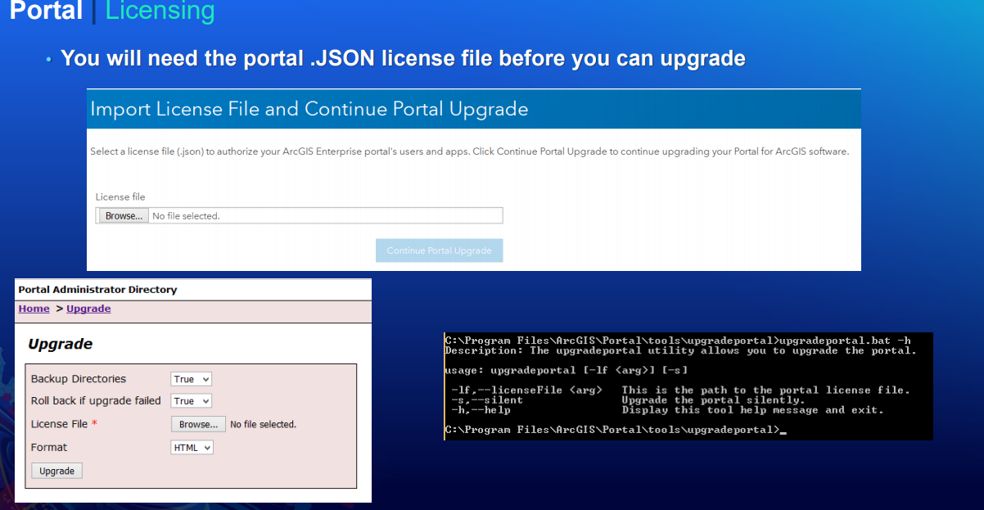

## Web Adaptor (Portal) – ws server

* 1. Uninstall
  2. Install
  3. Configure – use the same information as before (cogmap)

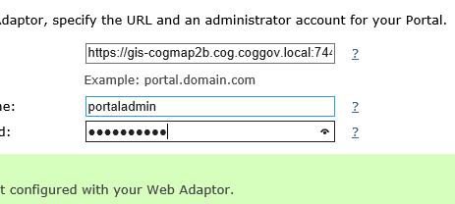 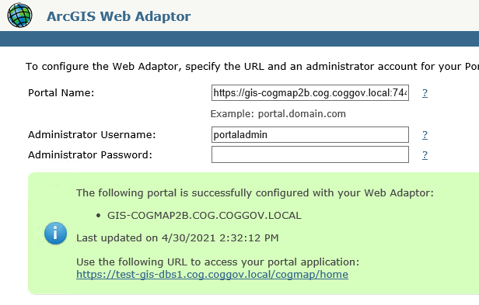 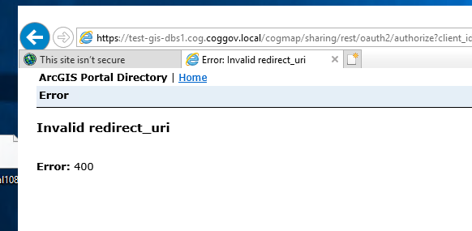

Can’t sign in to portal

Login to portaladmin

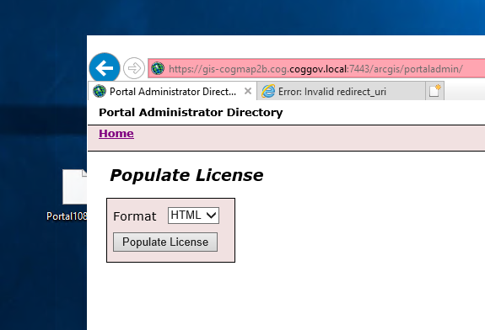 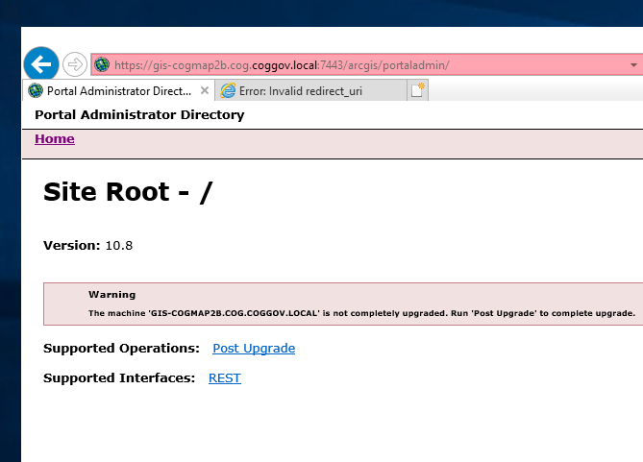 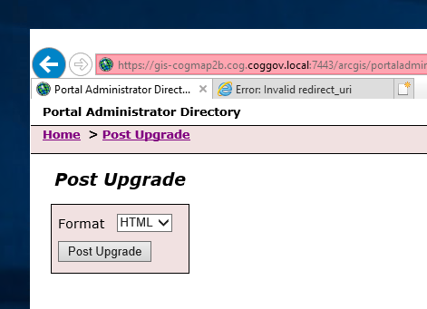

## Web Styles for Portal

* 1. Install

## ArcGIS Server

* 1. Install
  2. ~~Authorize~~
  3. Configure and waiting for server to upgrade its files.

## Web Adaptor (Server) – ws server

* 1. Unregister with server

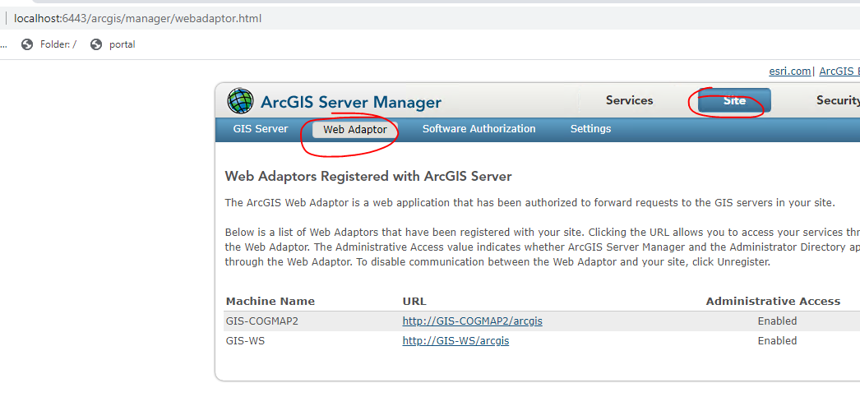

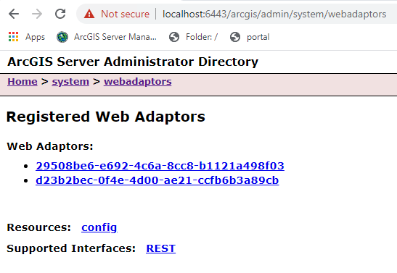 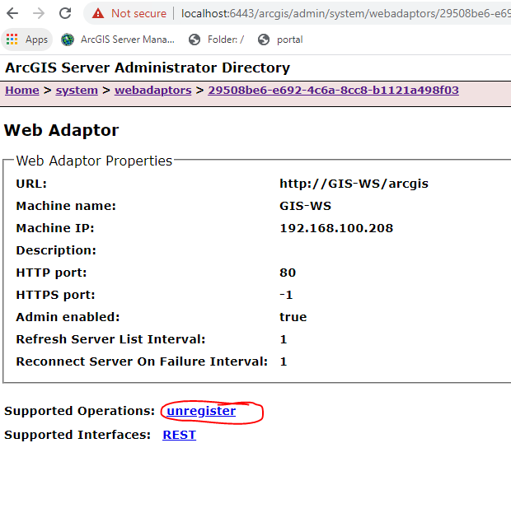

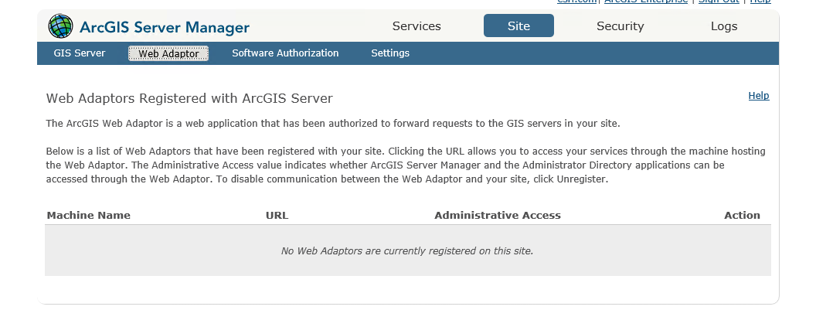

* 1. Uninstall
  2. Install
  3. Configure – use the same information as before

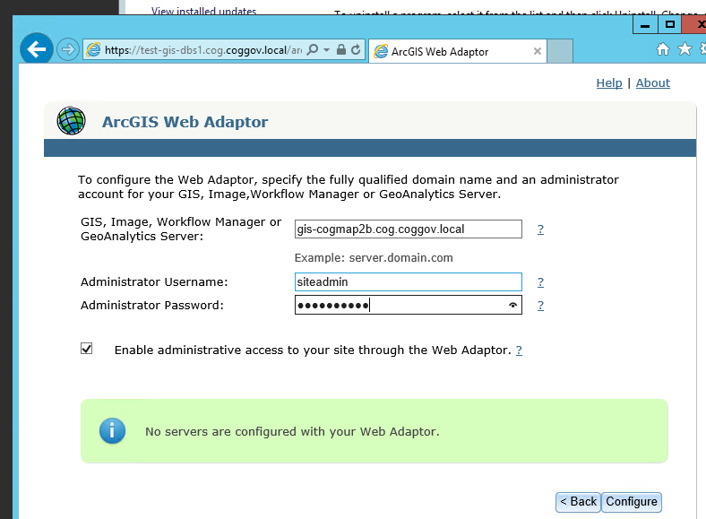

## Data Store

* 1. Install
  2. Configure
  3. upgrade

## David’s extension

* 1. ~~Uninstall~~
  2. ~~Install~~
  3. Upgrade with installation file

## ArcGIS desktop

* 1. Uninstall
  2. Install

## Federate

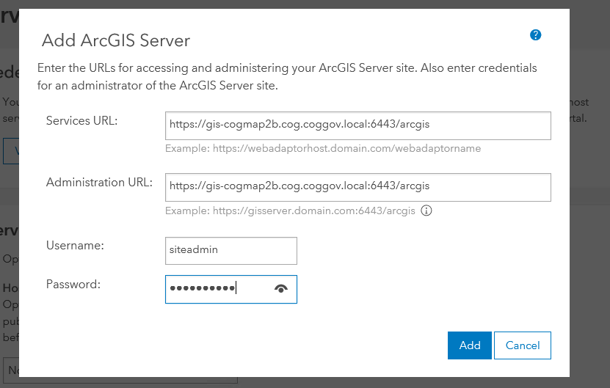

# Validate Upgrade

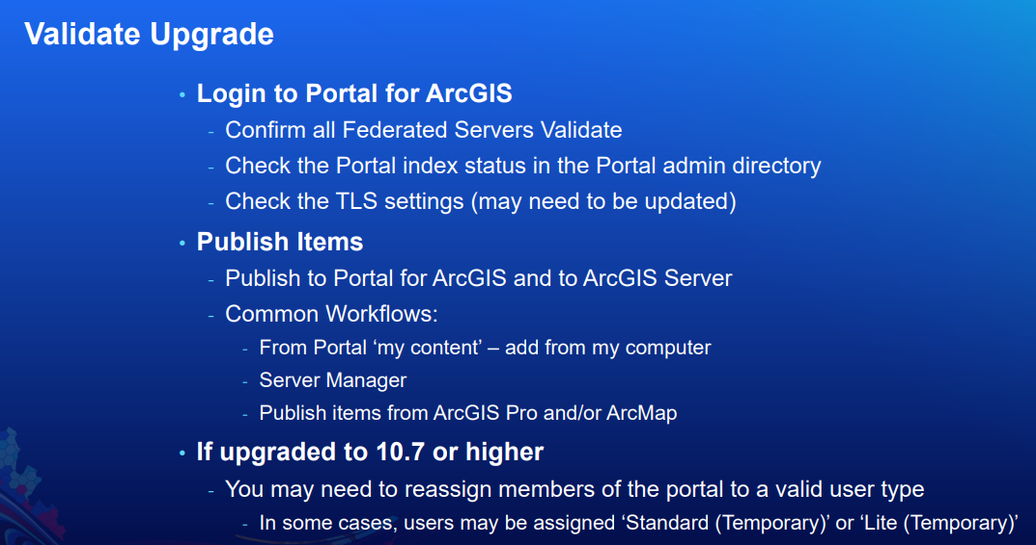

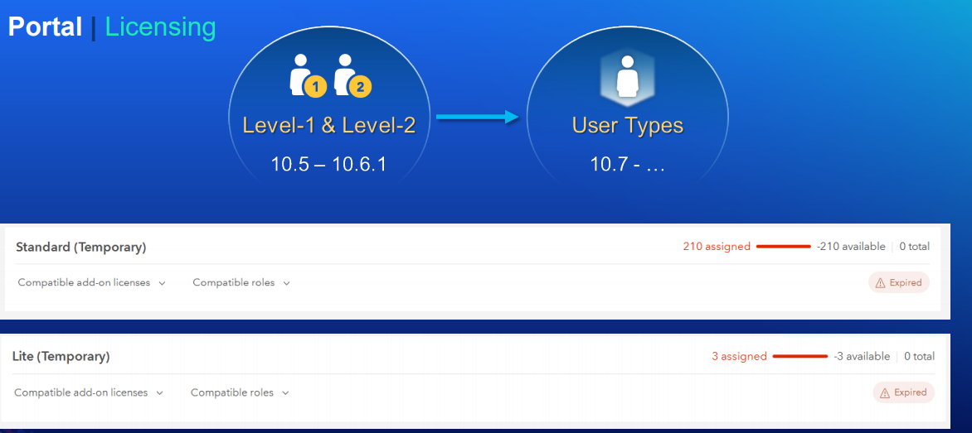

Reset server connections

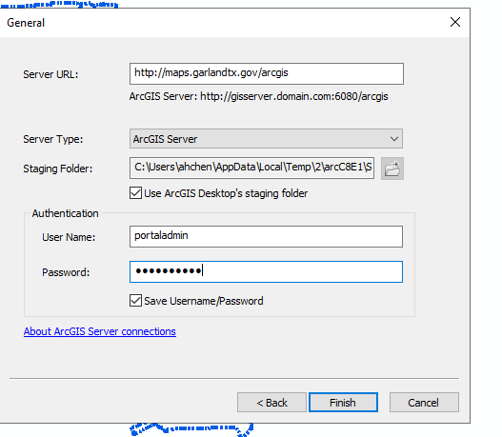

# Security best practices

1. Disable the Services Directory

<https://enterprise.arcgis.com/en/server/latest/administer/windows/disabling-the-services-directory.htm>

The Services Directory provides a browseable HTML-based representation of all your ArcGIS Server web services and the actions you can perform on them through REST. The Services Directory can be a useful development tool; however, Esri recommends that you disable the Services Directory for production systems when you don't want users browsing your list of services, finding your services in a web search, or making requests to your services through HTML forms.

Use the ArcGIS Server Administrator Directory to disable the Services Directory.

* Open the Administrator Directory and log in with an account that has been granted administrative privileges.
* The Administrator Directory URL is in the form http://gisserver.domain.com:6080/arcgis/admin.
* Access the Services Directory settings by clicking system > handlers > rest > servicesdirectory > edit.
* Uncheck Services Directory Enabled and click Save.

1. 

New!

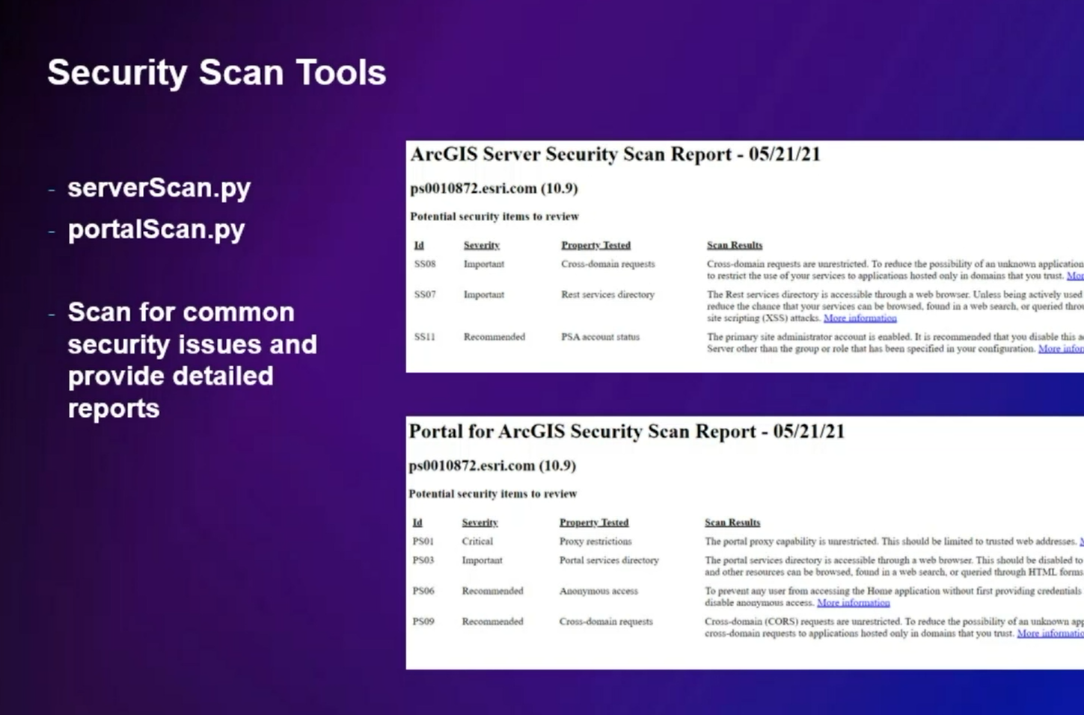

# Apply to gis-cogmap

1. Check system health - validate server data store; check portal index;

2. Backup files with ESRI webgisdr tool.

3. Upgrade to 10.8.1

3.1 upgrade portal - generate portal license json; Upgrade with installation file; import license file and continue portal upgrade。

3.2 upgrade web adaptor for portal on gis-ws server - uninstall old version; install new version; configure it with the exact same information as before.

3.3 install web styles for portal.

3.4 upgrade ArcGIS server - upgrade with installation file; configure and waiting for server to upgrade its files.

3.5 upgrade web adaptor for server on gis-ws server - unregister the web adaptor with server from server administrator directory; uninstall old version; install new version; configure it with the exact same information as before.

3.6 upgrade data store - upgrade with installation file; configure it.

3.7 upgrade Garland UtilityID tool and StreetExt tool (David's extension) - upgrade with installation file.

3.8 upgrade ArcGIS Desktop - uninstall the old version; install the new version.

3.9 install ArcGIS Pro.

4.0 federate server and portal - Add server from Portal admin page.

4. Validate upgrade

4.1 portal - login to portal; validate federated servers; check the portal index status in the portal admin directory; check the TLS settings;

4.2 publish items - from ArcGIS desktop; from ArcGIS pro; from portal 'my content', and add data from my computer directly;

4.3 check if users are under valid user types.

4.4 check some existing maps and tools - mygarland; bond map; cogmaps;

5. security best practices

5.1 check for updates / patch - install all patches

5.2 ArcGIS server

5.2.1 enable and use https - from ArcGIS Server Admin Directory (Home> security > config > update)

5.2.2 disable the services directory (recommended not to expose REST service directory on Prod Servers) - from ArcGIS Server Admin Directory (Home> system> handlers> rest> servicedirectory)

5.3 portal

5.3.1 enforce HTTPS so that all communication in our portal is encrypted.

5.3.2 disable ArcGIS Portal Directory - https://enterprise.arcgis.com/en/portal/latest/administer/windows/disabling-the-arcgis-portal-directory.htm